1. **Variable, Constant in PHP**

<!-- variables, constant program | Shubham Dahiya -->

<!DOCTYPE html>

<html>

<body>

<?php

// variables

$x = 10;

$y = 20;

$text = $x + $y;

// constants

define("Name", "ShubhamDahiya", true);

echo $x + $y ."<br> ";

echo Name;

?>

</body>

</html>

**OUTPUT:**

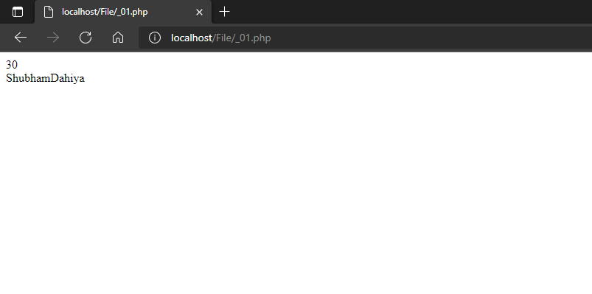

1. **Arithmethic + increment/decrement Operator in PHP**

<!-- arithmetic + increment/decrement operator program | Shubham Dahiya -->

<!DOCTYPE html>

<html>

<body>

<?php

$a = 42;

$b = 20;

echo "a = $a <br> b = $b <br> <br>";

$result = $a + $b;

echo "Addtion Operator: $result <br/>";

$result = $a - $b;

echo "Substraction Operator: $result <br/>";

$result = $a * $b;

echo "Multiplication Operator: $result <br/>";

$result = $a / $b;

echo "Division Operator: $result <br/>";

$result = $a % $b;

echo "Modulus Operator: $result <br/>";

//  exponential operator not working

//  $result = $a ** $b;

//  echo "Exponential Operator : $result <br/>";

$result = $a++;

echo "Increment Operator: $result <br/>";

$result = $a--;

echo "Decrement Operator: $result <br/>";

?>

</body>

</html>

**OUTPUT:**

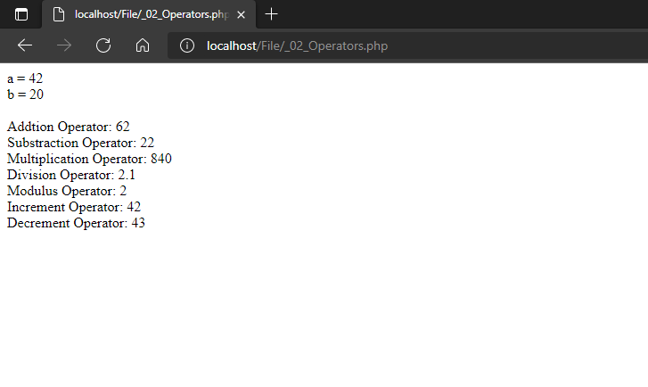

1. **Assignment Operator Program in PHP**

<!-- assignment operator program | Shubham Dahiya -->

<!DOCTYPE html>

<html>

<body>

<?php

$a = 17;

$b = 10;

echo "a = $a <br> b = $b <br> <br>";

$result = $a + $b;

echo "result = a + b : $result <br/>";

$result += $a;

echo "result += a : $result <br/>";

$result -= $a;

echo "result -= a : $result <br/>";

$result *= $a;

echo "result *= a : $result <br/>";

$result /= $a;

echo "result /= a : $result <br/>";

$result %= $a;

echo "result %= a : $result <br/>";

?>

</body>

</html>

**OUTPUT:**

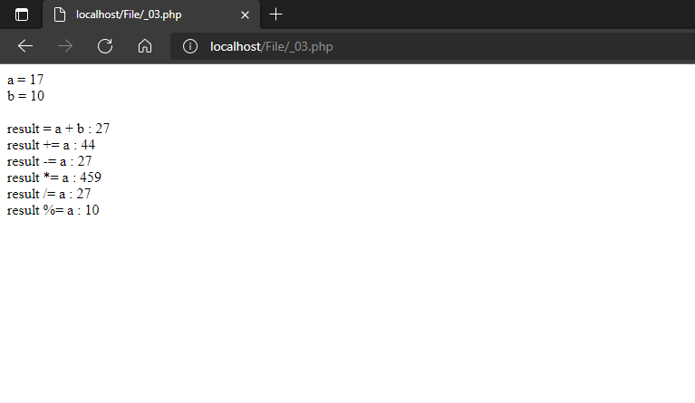

1. **Comparison Operator Program in PHP**

<!-- comparison operator program | Shubham Dahiya -->

<!DOCTYPE html>

<html>

<body>

<?php

$a = 15;

$b = 20;

echo "a = $a <br> b = $b <br> <br>";

if( $a == $b ) {

echo "Result1 : a is equal to b<br/>";

}else {

echo "Result1 : a is not equal to b<br/>";

}

echo "<br>";

if( $a > $b ) {

echo "Result2 : a is greater than  b<br/>";

}else {

echo "Result2 : a is not greater than b<br/>";

}

echo "<br>";

if( $a < $b ) {

echo "Result3 : a is less than  b<br/>";

}else {

echo "Result3 : a is not less than b<br/>";

}

echo "<br>";

if( $a != $b ) {

echo "Result4 : a is not equal to b<br/>";

}else {

echo "Result4 : a is equal to b<br/>";

}

echo "<br>";

if( $a >= $b ) {

echo "Result5 : a is either greater than or equal to b<br/>";

}else {

echo "Result5 : a is neither greater than nor equal to b<br/>";

}

echo "<br>";

if( $a <= $b ) {

echo "Result6 : a is either less than or equal to b<br/>";

}else {

echo "Result6 : a is neither less than nor equal to b<br/>";

}

?>

</body>

</html>

**OUTPUT: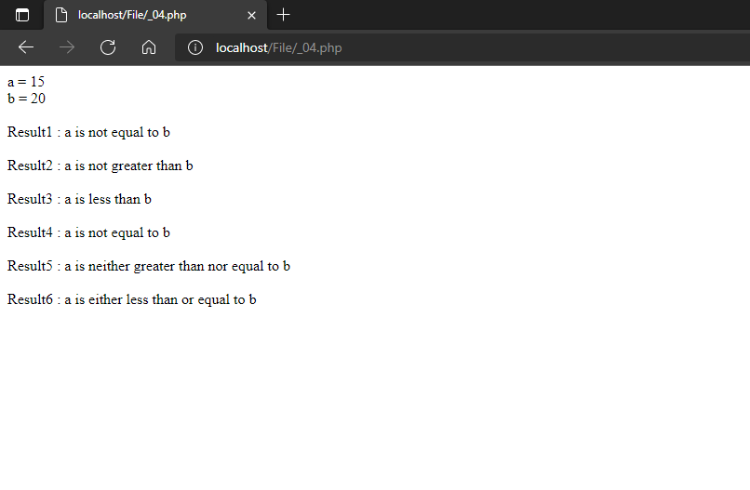:**

1. **Else-if program in PHP**

<!-- Else-if program | Shubham Dahiya -->

<!DOCTYPE html>

<html>

<body>

<?php

$age = 20;

echo "age = $age <br> <

<?php

$day = "5";

switch ($day) {

case "1":

echo "It is Monday!";

break;

case "2":

echo "It is today!";

break;

case "3":

echo "It is Wednesday!";

break;

case "4":

echo "It is Thursday!";

break;

case "5":

echo "It is Friday!";

break;

case "6":

echo "It is Saturday!";

break;

case "7":

echo "It is Sunday!";

break;

default:

echo "Invalid number!";

}

?>br>";

if ($age < 18)

{

echo "Your age is less than 18!";

}

elseif ($age >+ 18 && $age < 30)

{

echo "Your age is between 18 and 30!";

}

elseif ($age >= 30 && $age < 50)

{

echo "Your age is between 30 and 50!";

}

else

{

echo "Your age is greater than 50!";

}

?>

</body>

</html>

**OUTPUT:**

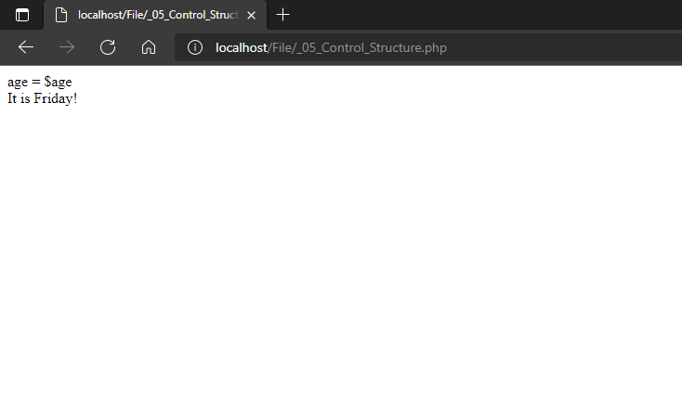

1. **Switch Program in PHP**

<!-- switch program | Shubham Dahiya -->

<!DOCTYPE html>

<html>

<body>

<?php

$day = "5";

echo "day= $day <br> <br>";

switch ($day) {

case "1":

echo "day is Monday!";

break;

case "2":

echo "day is today!";

break;

case "3":

echo "day is Wednesday!";

break;

case "4":

echo "day is Thursday!";

break;

case "5":

echo "day is Friday!";

break;

case "6":

echo "day is Saturday!";

break;

case "7":

echo "day is Sunday!";

break;

default:

echo "Invalid number!";

}

?>

</body>

</html>

**OUTPUT:**

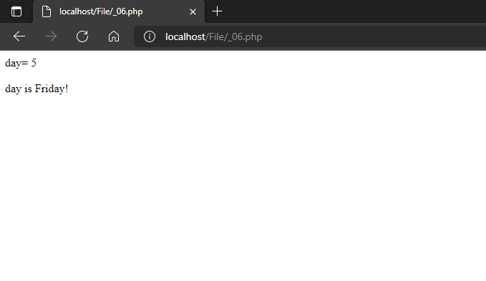

1. **While-Loop program in PHP**

<!-- while-loop program | Shubham Dahiya -->

<!DOCTYPE html>

<html>

<body>

<?php

$i=1;

while($i<=5){

echo "The number is " . $i . "<br>";

$i++;

}

?>

</body>

</html>

**OUTPUT:**

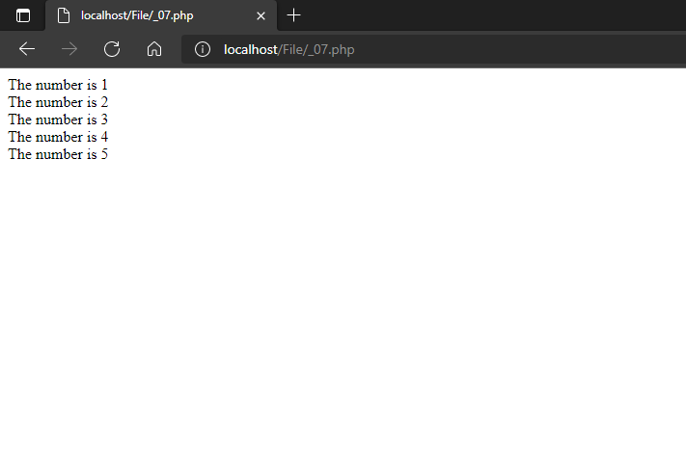

1. **Do-While program in PHP**

<!-- do-while program | Shubham Dahiya -->

<!DOCTYPE html>

<html>

<body>

<?php

$x = 1;

do {

echo "1 is not greater than 10." . "<br>";

$x++;

} while ($x > 10);

echo $x;

?>

</body>

</html>

**OUTPUT:**

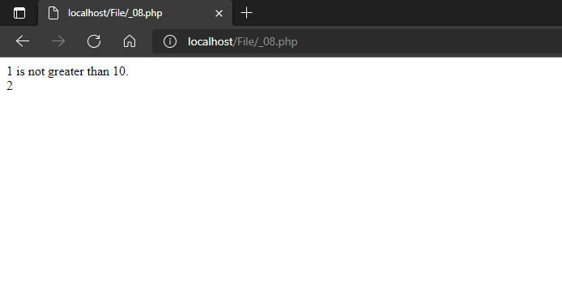

1. **For-Loop  program in PHP**

<!-- for-loop  program | Shubham Dahiya -->

<!DOCTYPE html>

<html>

<body>

<?php

for ($i=1; $i<=10; ++$i)

{

echo "The square of $i is ". $i * $i . ".</br>";

}

?>

</body>

</html>

**OUTPUT:**

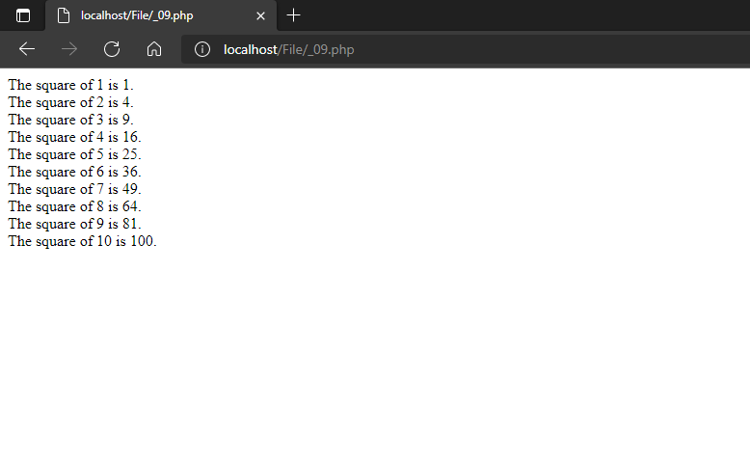

1. **For-Each Loop Program in PHP**

<!-- for-each loop program | Shubham Dahiya -->

<!DOCTYPE html>

<html>

<body>

<?php

$fruits = array('apple', 'banana', 'orange', 'grapes');

foreach ($fruits as $fruit)

{

echo $fruit;

echo "<br/>";

}

?>

</body>

</html>

**OUTPUT:**

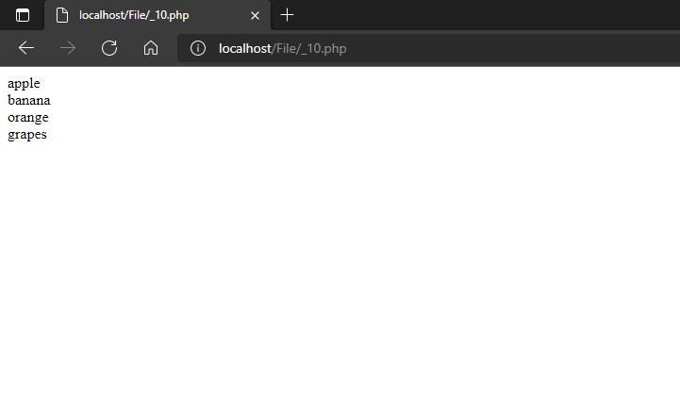

1. **Array Program in PHP**

<!-- Array program | Shubham Dahiya -->

<!DOCTYPE html>

<html>

<body>

<?php

/* 1st simple method */

$numbers = array( 1, 2, 3, 4, 5);

foreach( $numbers as $value ) {

echo "Value is $value <br />";

}

echo "<hr>";

/* Second method to create array. */

$numbers[0] = "one";

$numbers[1] = "two";

$numbers[2] = "three";

$numbers[3] = "four";

$numbers[4] = "five";

foreach( $numbers as $value ) {

echo "Value is $value <br />";

}

?>

</body>

</html>

**OUTPUT:**

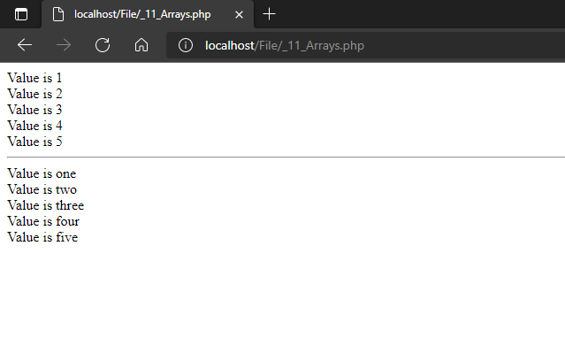

1. **Associative Array Program in PHP**

<!-- Associative Array program | Shubham Dahiya -->

<!DOCTYPE html>

<html>

<body>

<?php

$students = array("student1"=>"Shubham", "student2"=>"Ankit", "student3"=>"Lakshay Valecha");

foreach($students as $key => $value) {

echo "Key=" . $key . ", Value=" . $value;

echo "<br>";

}

?>

</body>

</html>

**OUTPUT:**

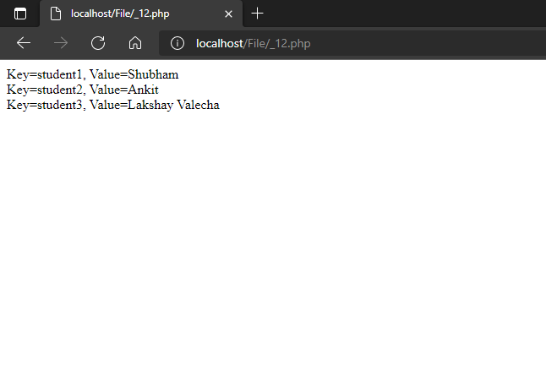

1. **Function - Global_variable program in PHP**

<!-- Function global_variable program | Shubham Dahiya -->

<!DOCTYPE html>

<html>

<body>

<?php

$name = "Shubham Dahiya";        //Global Variable

function global_var()

{

global $name;       //can't access name without declaring like this inside function

echo "Variable inside the function: ". $name;

echo "</br>";

}

global_var();

echo "Variable outside the function: ". $name;

?>

</body>

</html>

**OUTPUT:**

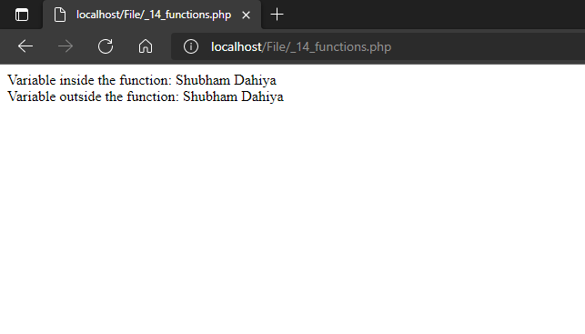

1. **Function $GLOBALS instead of global program in PHP**

<!-- Function $GLOBALS instead of global program | Shubham Dahiya -->

<!DOCTYPE html>

<html>

<body>

<?php

$num1 = 5;      //global variable

$num2 = 13;     //global variable

function global_var()

{

// IMPORTANT

$sum = $GLOBALS['num1'] + $GLOBALS['num2'];

echo "Sum of global variables is: " .$sum;

}

global_var();

?>

</body>

</html>

**OUTPUT:**

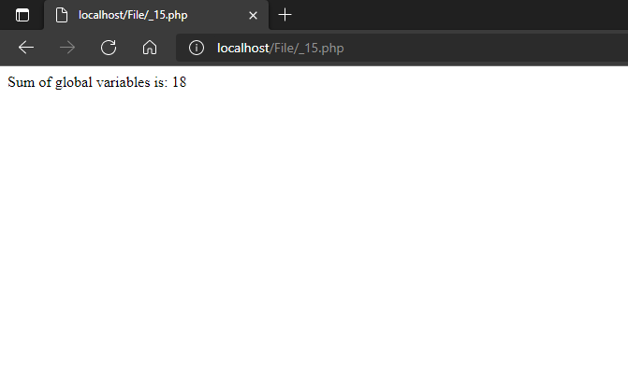

1. **Static variable Program in PHP**

<!-- static vairable program | Shubham Dahiya -->

<!DOCTYPE html>

<html>

<body>

<?php

function static_var()

{

static $num1 = 3;       //static variable

$num2 = 6;          //Non-static variable

//increment in non-static variable

$num1++;

//increment in static variable

$num2++;

echo "Static: " .$num1 ."</br>";

echo "Non-static: " .$num2 ."</br>";

}

//first function call

static_var();

//second function call

static_var();

?>

</body>

</html>

**OUTPUT:**

